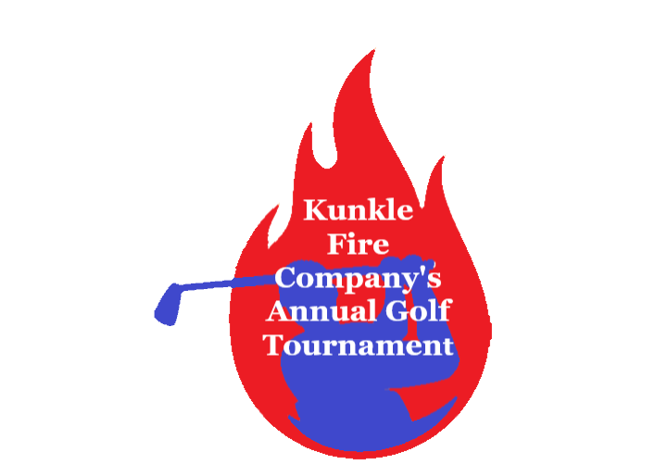
Kunkle Fire Company’s
Annual Golf Outing
Thursday July 13^{th,} 2023
At Irem Country Club
(Please make checks payable to Kunkle Fire Company 3943 SR 309 HWY Dallas PA 18612)

Name:______________________________________________

Proper Mailing Address: __________________________________________________________________________________________________________________________________________________________________
Phone Number:___________________________________

Amount of Donation:______________________________
THANK YOU FOR YOUR SUPPORT!
Hole Sponsor Categories:
Fire Commissioner Sponsor………$500
Fire Chief Sponsor…………………….$250
Fire Captain Sponsor………………...$100
Firefighter Sponsor………………….….$50

