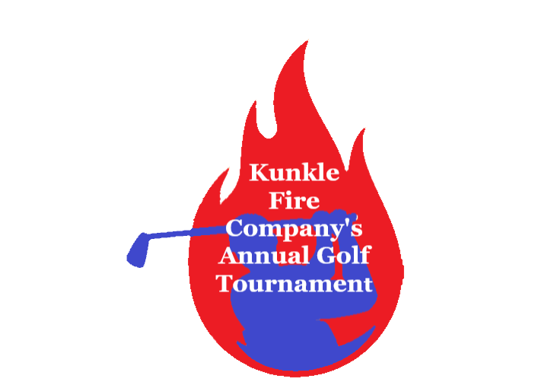
Kunkle Fire Company’s
Annual Golf Outing
Thursday July 13th, 2023
At Irem Country Club

Captain & Crew
Registration Starts at 11 AM
Shotgun Start at Noon

Cost $125 per Golfer
(PRICE INCLUDES GREEN FEES, CART, SNACKS, DINNER, BEER, WATER AND SODA)

ALL GOLFERS MUST BE PAID IN FULL BY JULY 6TH 2023

MAKE / MAIL CHECKS PAYABLE TO KUNKLE FIRE COMPANY
3943 SR 309 HWY DALLAS PA 18612

CAPTAIN 1: _______________________________
GOLFER 2:_______________________________
GOLFER 3:_______________________________
GOLFER 4:_______________________________

RAFFLES / DOOR PRIZES / FLIGHT AWARDS

